Permanently or Temporarily Assigning a Custom Work Schedule Quick Reference Guide
Last Updated: 1/18/2019
This QRG outlines the steps required to assign an individual (“custom”) work schedule permanently or temporarily. Users with the Business Support role can perform this task. The Time Profile, Time Recording Profile, and Variant Cheat Sheet provides guidance regarding schedules that should be assigned/created based on the attributes of the employee/their position.
Important notes for assigning/creating schedules for individuals with less than 1.0 FTE
- Non-exempt employees: The number of hours of the work schedule assigned to / created for the employee must match the individual’s FTE (based on a 40 hour workweek). Failure to properly assign/create the schedule will result in pay errors as pay, including holiday pay, is derived from the schedule for the individual. It also will impact Time Off requests. Non-exempt employees who are assigned the Webclock time entry method should be assigned the AdHoc Monday through Friday (AdHocMF) schedule. It is important to review the available schedules before building a custom schedule.
- Fiscal Year (FY) Exempt employees: Choose schedule Exempt – Monday to Friday – 8 hours, regardless of FTE. Additional standard options for FY schedules will be built after the initial SuccessFactors implementation.
- Academic Year (AY) Exempt employees: Choose the AY schedules for the appropriate campus (AY-NW, AY-FW, AY-WL). Failure to properly assign/create the schedule will impact the individual’s ability to request Time Off in multiple day increments.

Other QRGs on this topic:
- Assigning a Non-Custom Work Schedule Permanently
- Assigning a Non-Custom Work Schedule Temporarily
Contents
Accessing An Employee’s Record in SuccessFactors 1
Building and Assigning a New Individual (“custom”) Schedule (Permanent or Temporary) 2
Editing or RemovingTemporary Schedules 5

Accessing An Employee’s Record in SuccessFactors
Visit OneCampus and select Employee Launchpad. |  | https://one.purdue.edu/  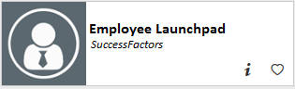
Log in using Purdue Career Account ID and BoilerKey passcode. |  | 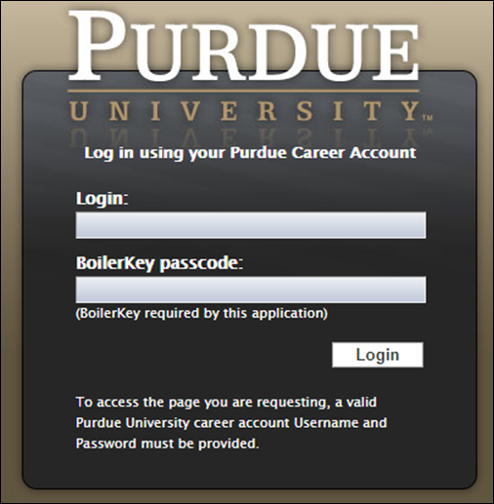
From the Employee Central Homepage, search for the target employee using the search feature. Click on the target employee once their name populates in the results. |  | 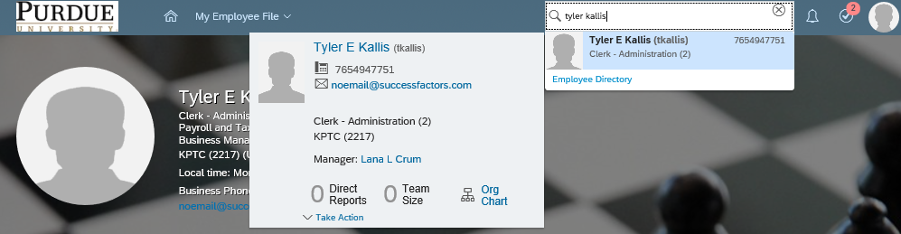

Building and Assigning a New Individual (“custom”) Schedule (Permanent or Temporary)
On the employee’s record,  Click Time Off tab,  Then click Administer Time > |  |  | 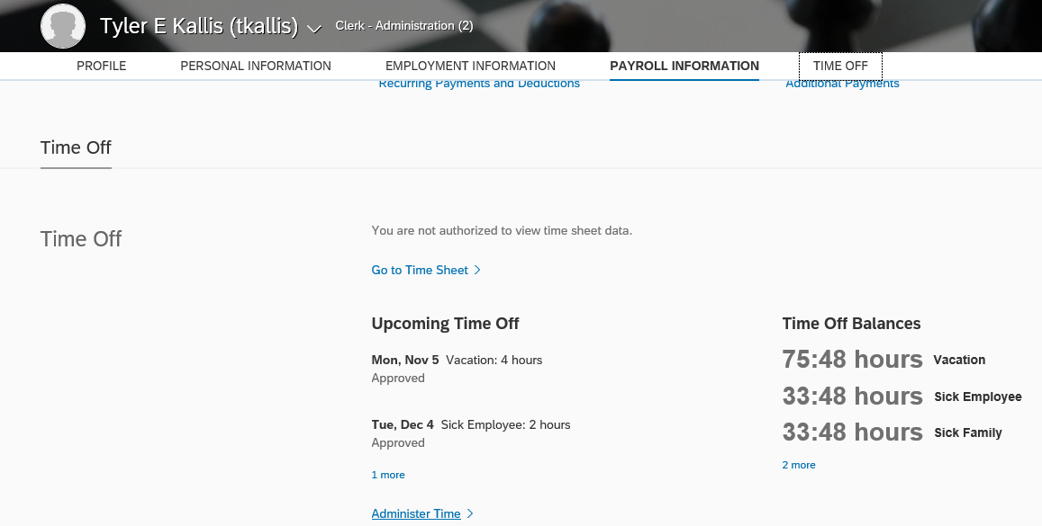  2  1
Click the Work Schedule tab.  The current schedule is displayed.  Click New Temporary Change.  Please note that it is important that the time entry method and work schedule be in agreement. Please see the Time Profile, Time Recording Profile, and Variant Cheat Sheet for guidance. |  |  | 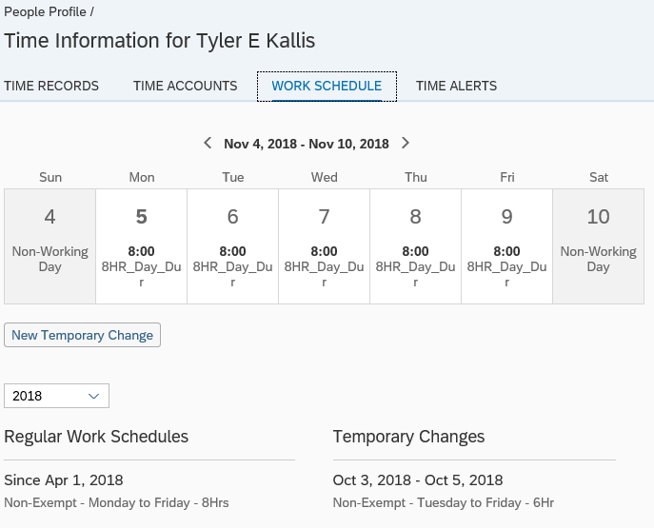  2  1
The New Temporary Change window displays.  Select a date range for the new temporary schedule by either typing the dates in MMM dd, yyyy format (ex. Jan 01, 2018) or clicking the calendar icon to select the start and end dates in the To which period should the temporary change apply? field  To assign temporarily, select the appropriate date range.  To assign “permanently”, select an end date 10 years in the future (this is the maximum amount). |  |  | 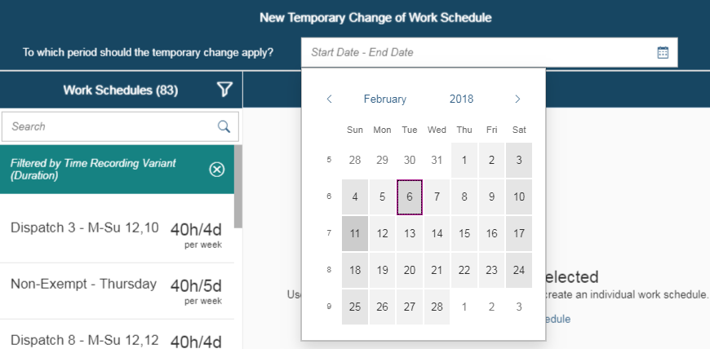
After selecting a date range within the New Temporary Change window, click New Individual Work Schedule to create a customized temporary schedule. |  |  |  | 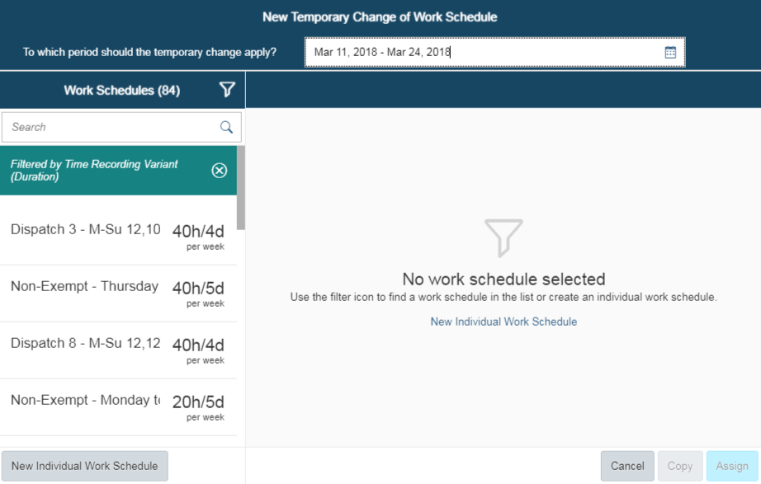
Click +Add to add more days to the schedule cycle.  Note: Non-Exempt employees must have a schedule that includes 7 days.  Expand the Category drop-down menu to select the appropriate type of hours for that day. See below for an explanation of each category. |  |  |  | 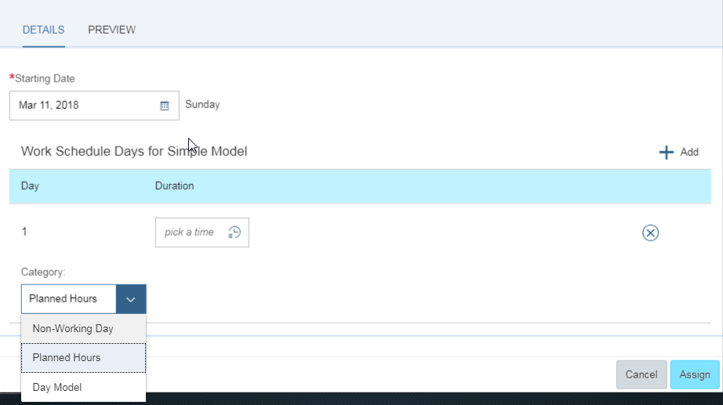
Non-Working Day means the employee is off of work and records no working hours. |  |  |  | 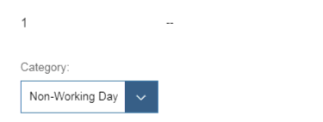
Planned Hours require user-entry of hours to be worked on that day. Hours can be entered via:  1) Numerical entry  2) Date selection scroll feature accessed by clicking the clock icon |  |  |  | 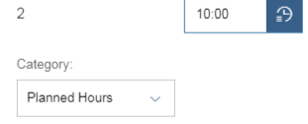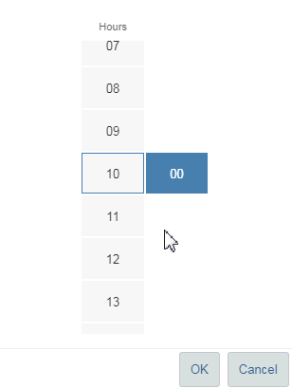
Day Model requires the user to select an option from a list of pre-built schedule duration models.  Expand the drop-down list and select the desired model. |  |  |  | 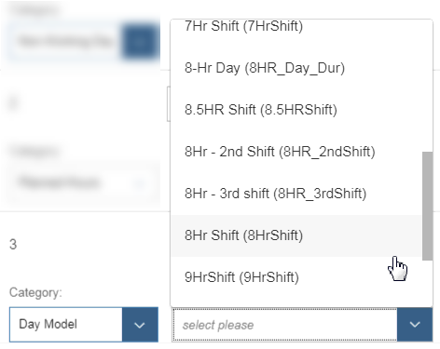
To preview the created schedule in calendar format, click the Preview tab.  To assign the newly created Individual Work Schedule, click Assign. |  |  |  | 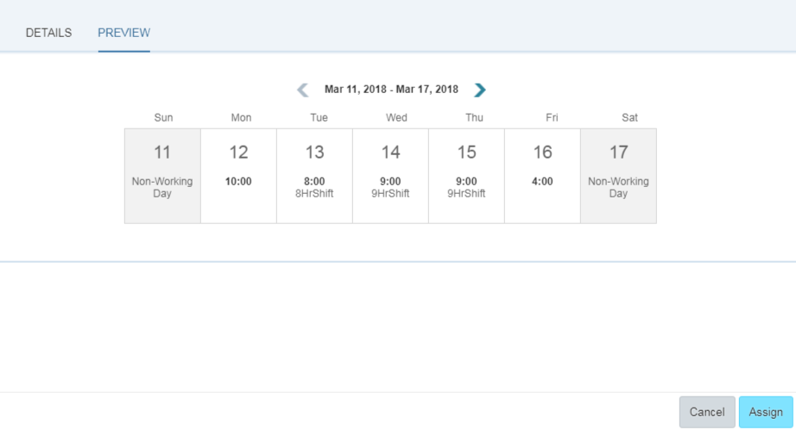
The New Individual Work Schedule appears under the Temporary Change section of the employee’s Work Schedule window. |  |  |  | 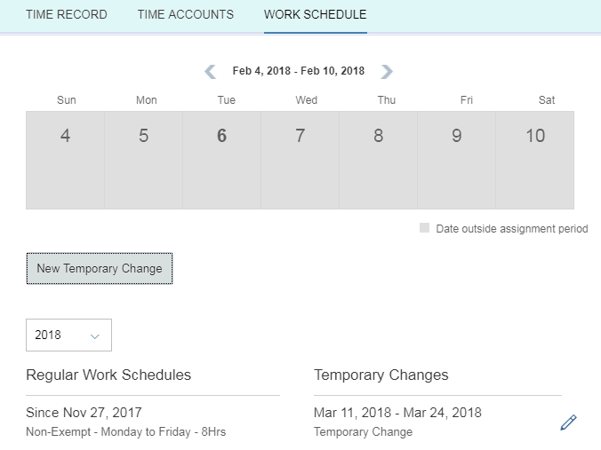

Editing or RemovingTemporary Schedules
On the employee’s record,  Click Time Off tab,  Then click Administer Time > | 2  1
Click the Work Schedule tab.  The current schedule is displayed.  Click the schedule listed under Temporary Changes that is to be edited/removed. | 2  1
The Edit Temporary Change window displays.  Note: Confirm that the selected date range is correct as opening the edit window may result in a changed date.  Make changes in the same manner as explained in the above New Individual Schedule section.  Additionally, arrows can be clicked to shift days around and clicking the x button will remove the associated day.  Click Cancel to cancel the edit.  Click Delete to delete the temporary change entirely.  Click Save to make the changes to the temporary schedule go into effect. | 